1 Create a image from running container.

🧰 Prerequisites (for Amazon Linux)

1. Update your system
sudo yum update -y

2. Install Docker
sudo amazon-linux-extras install docker -y
or (for Amazon Linux 2023+):
sudo dnf install docker -y

3. Start and enable the Docker service
sudo systemctl start docker
sudo systemctl enable docker

4. Add your user to the docker group (optional but recommended)
sudo usermod -aG docker $USER
Then log out and back in (or run newgrp docker) so the change takes effect.

5. Verify Docker is running
docker ps
If you see no errors, Docker is active.

Step-by-Step Process: Create an Image from a Running Container

Step 1: Run a test container
Let’s start with an Nginx container:
docker run -d --name nginx-container -p 8080:80 nginx
Check it’s running:
docker ps

Step 2: (Optional) Make some changes inside the container
For example, customize the Nginx welcome page:
docker exec -it nginx-container bash
Inside the container:
echo "<h1>Hello from Amazon Linux Nginx!</h1>" > /usr/share/nginx/html/index.html
exit

Use apt to install vi or nano (if you can install packages)
If your container has apt (like Debian/Ubuntu based images): for linux image add yum
apt update
apt install -y vim
or a smaller editor:
apt install -y nano
Then open your file:
vi /usr/share/nginx/html/index.html
or
nano /usr/share/nginx/html/index.html

Step 3: Commit the container to a new image
docker commit nginx-container nginx-custom:v1
Explanation:
- nginx-container → running container name
- nginx-custom → new image name
- v1 → version tag

Step 4: Verify the image
docker images
Example:
REPOSITORY TAG IMAGE ID CREATED SIZE
nginx-custom v1 7e4b5e3f3d02 10 seconds ago 133MB

Step 5: Run a new container from your custom image
docker run -d --name test-nginx -p 8081:80 nginx-custom:v1
Now open your EC2 Public IP on port 8081 in a browser:
http://<EC2-Public-IP>:8081
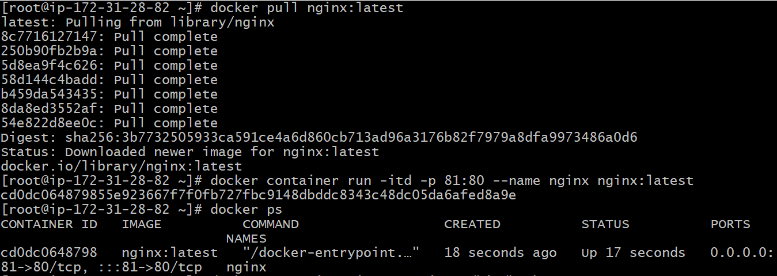
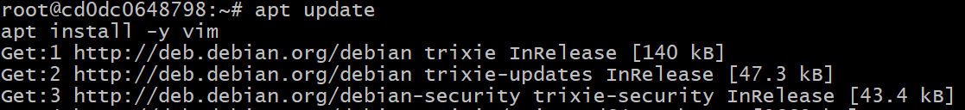
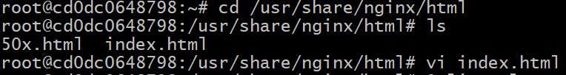
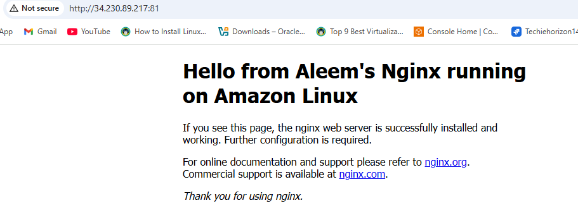
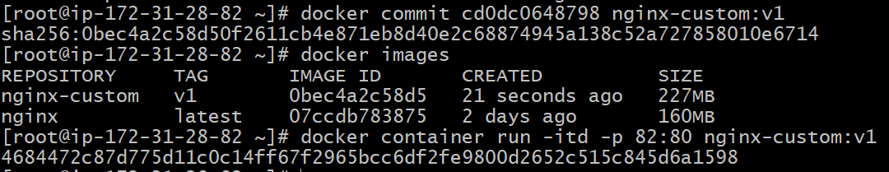
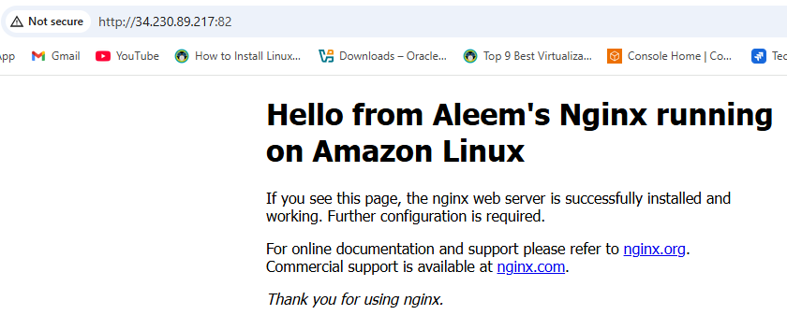
2 Copy image from local machine to docker server and load the image.

Step 1 — Save the Docker image as a tar file (on your local machine)
List your local images first:
docker images
Then save the desired image (example: myapp:latest) to a .tar file:
docker save -o myapp.tar myapp:latest
✅ This creates a file named myapp.tar containing your Docker image.

Step 2 — Copy the tar file to your Docker server
If you have SSH access to your server, use scp (secure copy):
scp myapp.tar ec2-user@<server-ip>:/home/ec2-user/
Example for Amazon Linux EC2:
scp -i mykey.pem myapp.tar ec2-user@3.85.45.12:/home/ec2-user/
✅ The file myapp.tar will now be on your Docker server.

Step 3 — Connect to your Docker server
SSH into your EC2 or remote Docker host:
ssh -i mykey.pem ec2-user@<server-ip>
If you’re root:
sudo su

Step 4 — Load the image into Docker
Once inside your Docker server, load the image using:
docker load -i myapp.tar
You should see output like:
Loaded image: myapp:latest

Step 5 — Verify the image
Check if it’s available:
docker images

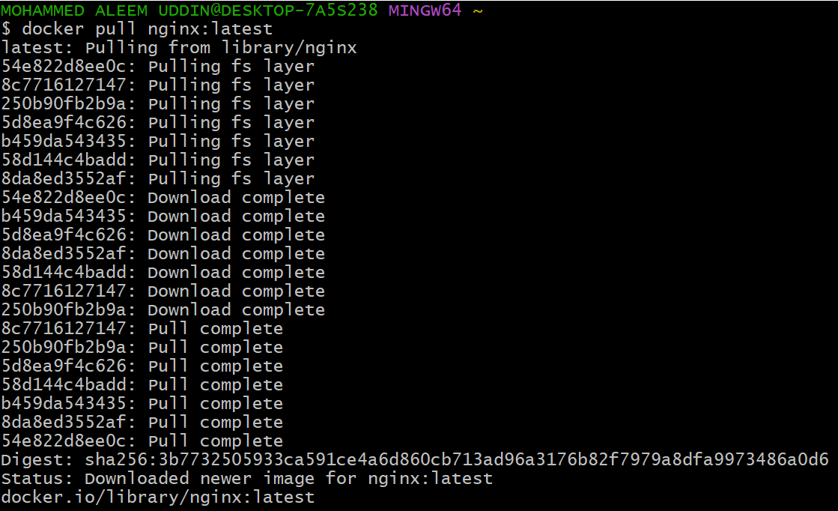
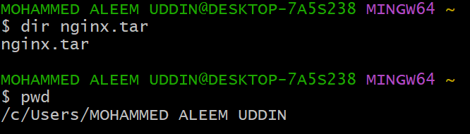
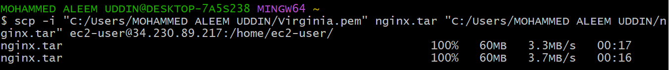
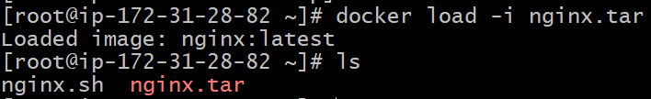
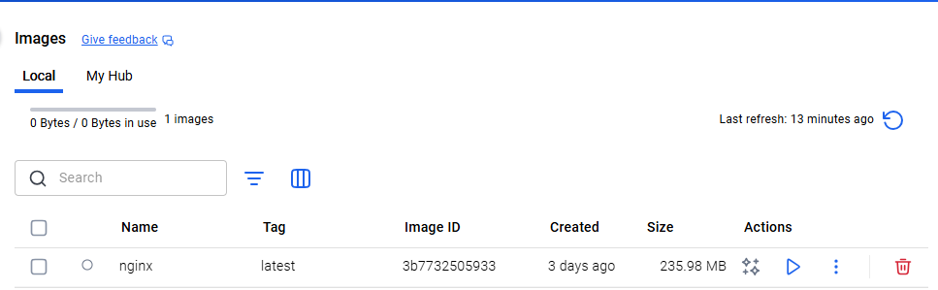

3 Create Docker image using alpine and customize with tomcat.

Step 1 — Create a working directory
mkdir tomcat-alpine
cd tomcat-alpine

Step 2 — Create a Dockerfile
Create a file named Dockerfile:
vi Dockerfile
Paste the following content inside
FROM alpine:latest

LABEL maintainer="you@example.com"
LABEL description="Tomcat on Alpine with OpenJDK 17"

RUN apk update && apk add --no-cache openjdk17-jre curl tar bash

RUN mkdir -p /usr/local/tomcat
WORKDIR /usr/local/tomcat

RUN curl -fSL https://dlcdn.apache.org/tomcat/tomcat-9/v9.0.110/bin/apache-tomcat-9.0.110.tar.gz -o apache-tomcat-9.0.110.tar.gz && \
tar -xzf apache-tomcat-9.0.110.tar.gz --strip-components=1 && \
rm apache-tomcat-9.0.110.tar.gz

EXPOSE 8080

CMD ["bin/catalina.sh", "run"]

Step 3: Build and test
docker build -t tomcat-alpine:latest .
If build succeeds, run:
docker run -d -p 8080:8080 --name tomcatserver tomcat-alpine:latest
Then check:
http://<your-ec2-ip>:8080

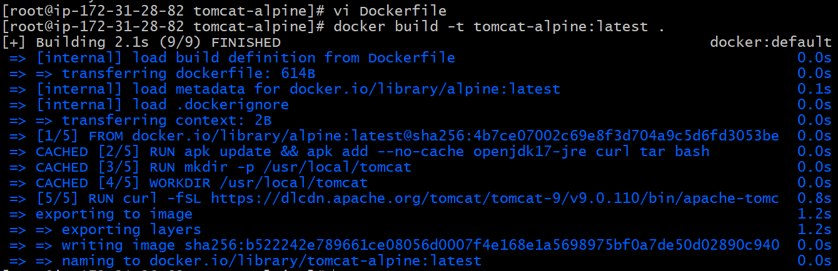
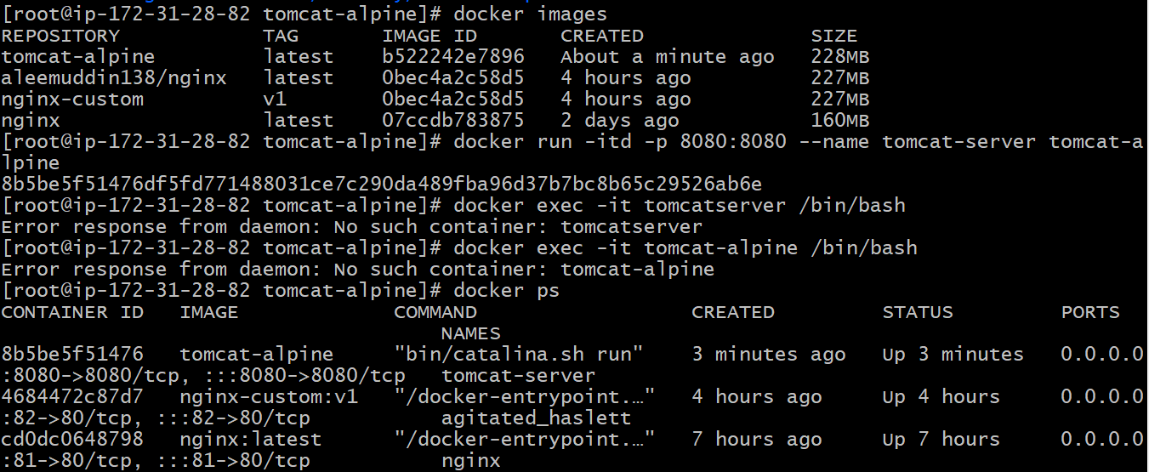
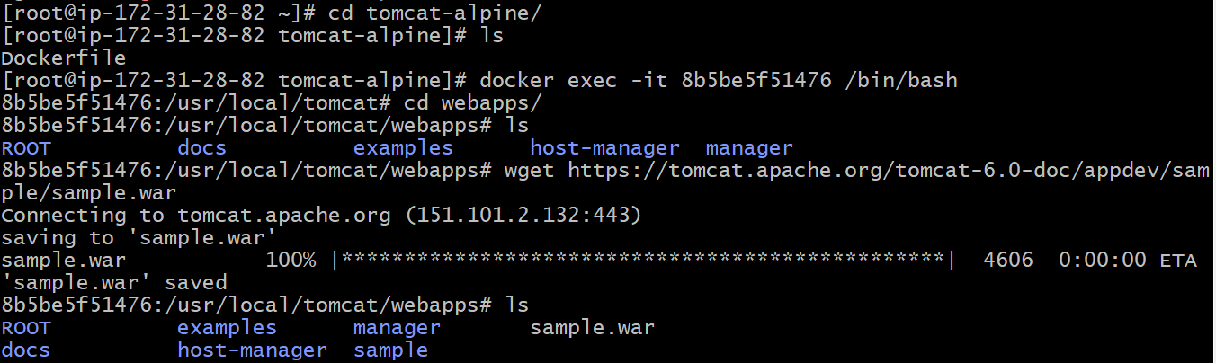
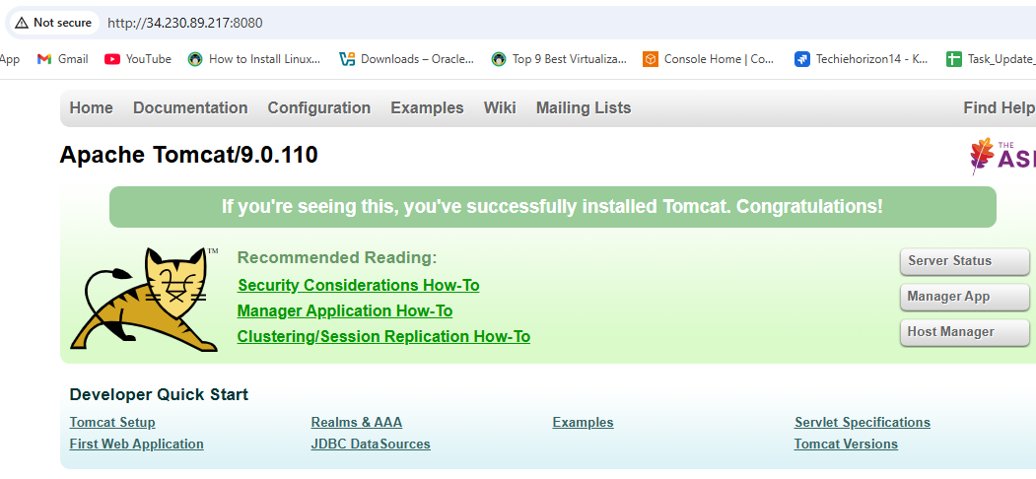
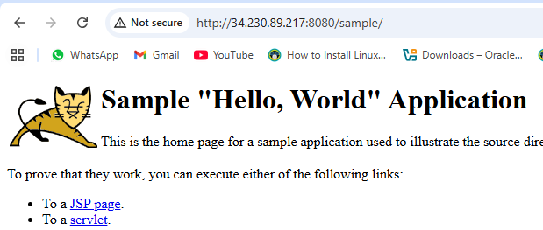
- Create single stage and multi stage docker file using this source Code https://github.com/ALEEMUDDIN138/multi-stage-example.git

Multi-Stage Dockerfile (Recommended)
Multi-stage builds allow you to separate the build environment from the runtime environment, resulting in smaller and more secure images.
# Build Stage
FROM maven:3.8.6-openjdk-17-slim AS builder
WORKDIR /app
COPY . .
RUN mvn clean package -DskipTests

# Runtime Stage
FROM openjdk:17-slim
WORKDIR /app
COPY --from=builder /app/target/*.jar app.jar
EXPOSE 8080
ENTRYPOINT ["java", "-jar", "app.jar"]
Explanation:
- The first stage (builder) uses Maven to build the application.
- The second stage (runtime) copies the built JAR file from the builder stage and sets up the runtime environment.
- This approach ensures that the final image contains only the necessary runtime components, reducing its size.

Build and Run Instructions
- Clone the Repository:
- git clone https://github.com/ALEEMUDDIN138/multi-stage-example.git
- cd multi-stage-example
- Build the Docker Image:
  - For the multi-stage Dockerfile:
docker build -t multi-stage-example:v1 .
Run the Docker Container:
docker run -p 8080:8080 multi-stage-example:v1
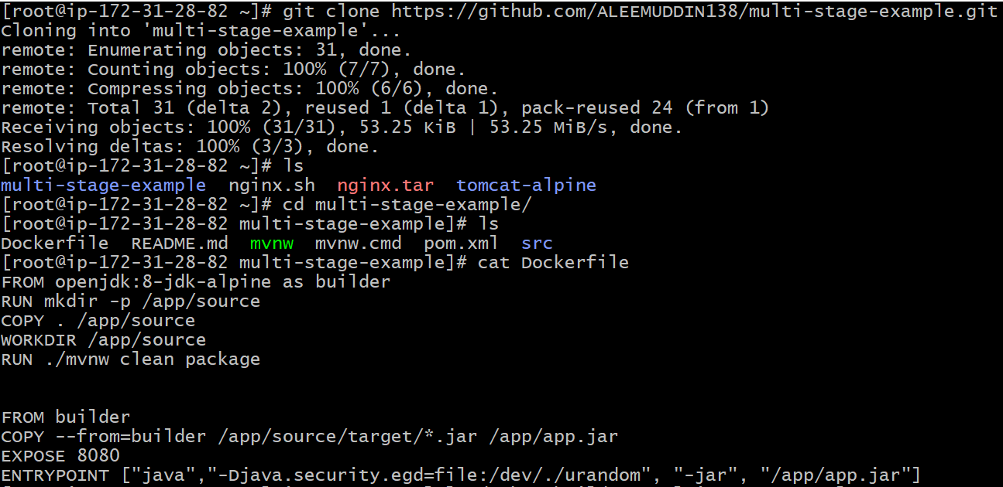
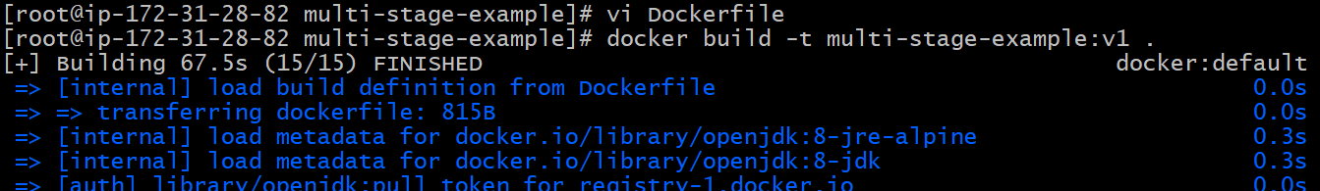
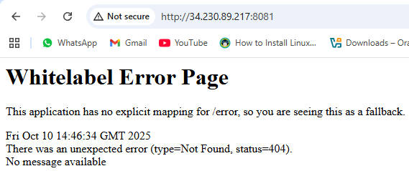
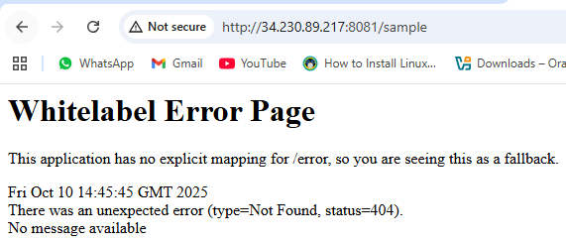

5 Install docker compose and execute sample application.

What is Docker Compose?
Docker Compose is a tool that helps you define, configure, and run multi-container Docker applications easily — using a simple YAML file (docker-compose.yml).
Instead of running multiple docker run commands manually, Docker Compose lets you define all your containers, networks, and volumes in one place, and then bring everything up with just one command:
docker-compose up

Step 1: Install Docker
Amazon Linux 2 comes with Docker available via the Amazon extras library.
sudo amazon-linux-extras install docker -y
sudo systemctl enable docker
sudo systemctl start docker
Add your user to the Docker group (so you don’t need sudo every time):
sudo usermod -aG docker $USER
Then log out and log back in (or run newgrp docker) for the change to take effect.
Check Docker:
docker --version

Step 2: Install Docker Compose
Amazon Linux doesn’t include Compose by default, so install it manually:
sudo curl -L "https://github.com/docker/compose/releases/latest/download/docker-compose-$(uname -s)-$(uname -m)" \
-o /usr/local/bin/docker-compose
Make it executable:
sudo chmod +x /usr/local/bin/docker-compose
Verify installation:
docker-compose --version
You should see something like:
docker-compose version 2.x.x

Step 3: Create a Sample Docker Compose Project
Create a new directory:
mkdir ~/sample-compose
cd ~/sample-compose
Create a docker-compose.yml file:
nano docker-compose.yml
Paste this:
version: "3.8"
services:
web:
image: nginx:latest
ports:
- "8080:80"
Save and exit (Ctrl+O, Enter, Ctrl+X).

Step 4: Start the Application
Run:
docker-compose –f <file name> up -d
Check running containers:
docker ps

Step 5: Test in Browser
In your browser, go to:
http://<your-EC2-public-IP>:8080
✅ You should see the Nginx Welcome Page.
(If not, make sure your EC2 instance’s security group allows inbound traffic on port 8080.)

Step 6: Stop and Clean Up
docker-compose –f <file name> down

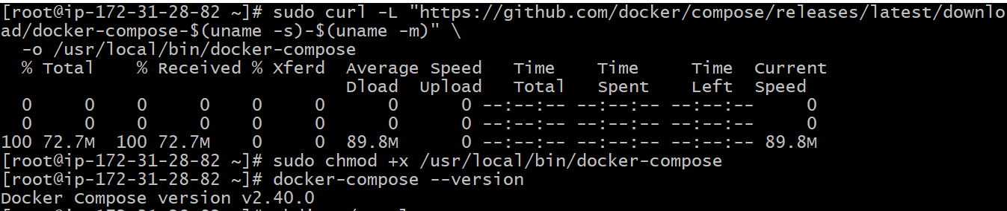
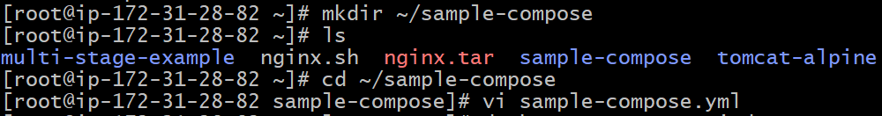
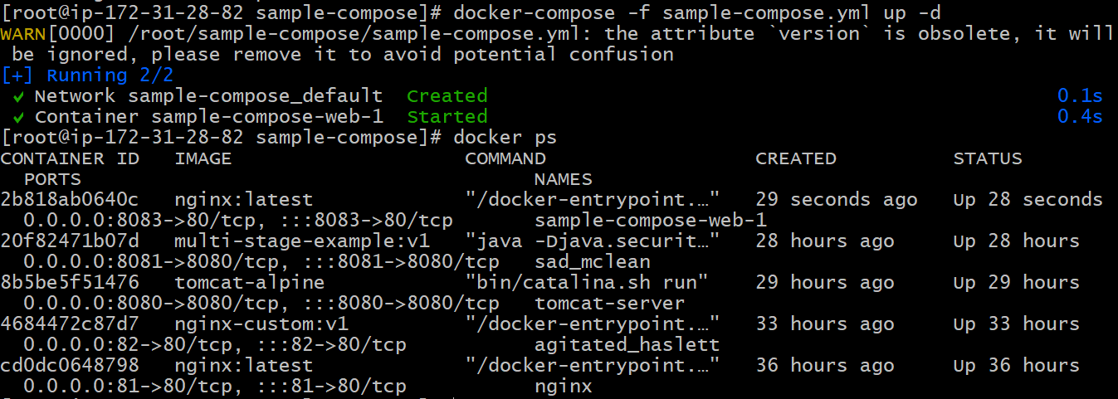
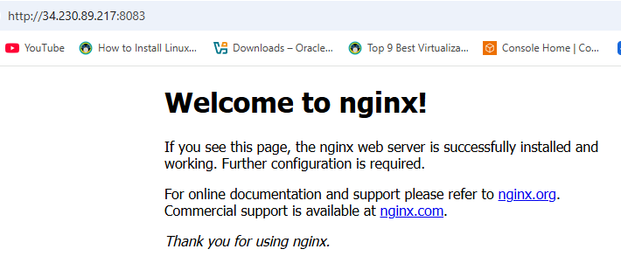
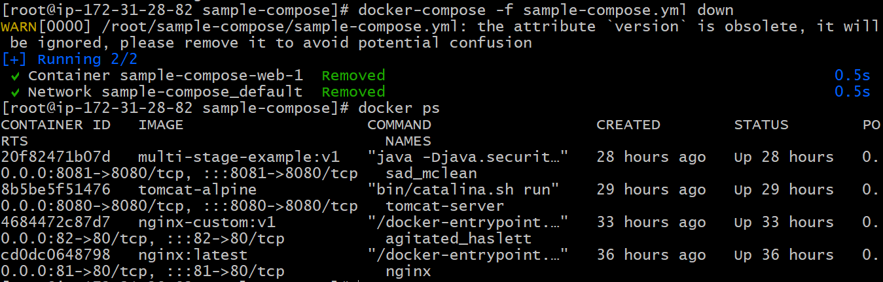
  - Implement solution to scan images when pushed to docker registry.

What is Docker Image Scanning?
Docker image scanning is the process of analyzing container images to find security vulnerabilities, misconfigurations, and outdated dependencies in the software packages that make up the image.
By scanning images:
- You ensure your containers are free from known CVEs (Common Vulnerabilities and Exposures).
- You comply with security best practices.
- You prevent deploying insecure applications to production.
Tools like Trivy automatically detect these vulnerabilities and show detailed reports.

Step 1: Install Docker on Amazon EC2 (Amazon Linux 2)
Run the following commands:
sudo yum update -y
sudo yum install docker -y
sudo systemctl start docker
sudo systemctl enable docker
sudo usermod -aG docker ec2-user
Note: After adding your user to the docker group, log out and log back in or run newgrp docker so you can use Docker without sudo.
Verify Docker is working:
docker version

Step 2: Install Trivy on Amazon Linux 2
Install dependencies:
sudo yum update -y
sudo yum install wget curl git -y
Download the latest Trivy binary:
wget https://github.com/aquasecurity/trivy/releases/download/v0.55.2/trivy_0.55.2_Linux-64bit.tar.gz
Extract and install:
tar zxvf trivy_0.55.2_Linux-64bit.tar.gz
sudo mv trivy /usr/local/bin/
Verify installation:
trivy --version
Expected output:
Version: 0.55.2

Step 3: Pull, Tag, and Push an Image to Docker Hub
Login to Docker Hub:
docker login
Pull the base image:
docker pull nginx:latest
Run it to verify:
docker container run -itd -p 80:80 nginx:latest
Tag the image for your Docker Hub account:
docker tag nginx:latest aleemuddin138/nginx:test
Push it to your Docker Hub repository:
docker push aleemuddin138/nginx:test

Step 4: Scan the Image with Trivy
Now scan the image on Docker Hub directly:
trivy image aleemuddin138/nginx:test

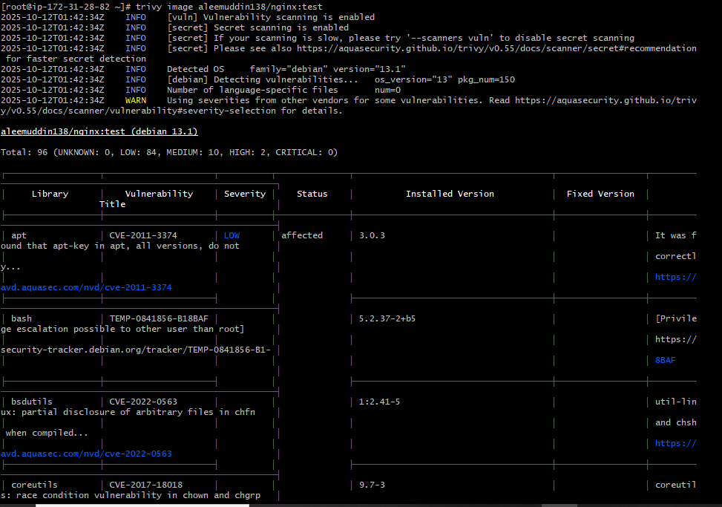
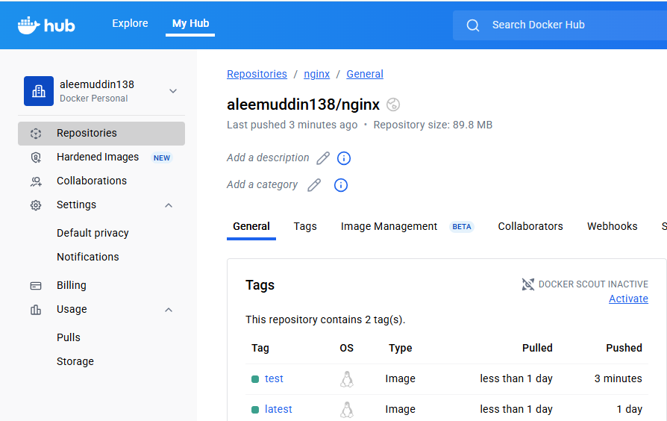
- Implement solution to scan images when pushed to AWS ECR.
Push to your own ECR account
If your IAM user belongs to account 123456789012, then:
- Create the repository in your own ECR:
aws ecr create-repository --repository-name myapp-repo --region us-east-1
- Tag your image with your own account ID:
docker tag nginx:latest <account id>.dkr.ecr.us-east-1.amazonaws.com/myapp-repo:latest
- Log in:
aws ecr get-login-password --region us-east-1 | docker login --username AWS --password-stdin <account id>.dkr.ecr.us-east-1.amazonaws.com
- Push:
docker push <account id>.dkr.ecr.us-east-1.amazonaws.com/myapp-repo:latest

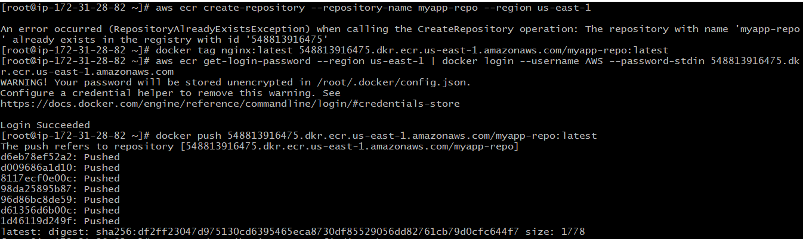

View Scan Results
Check scan results via CLI:
aws ecr describe-image-scan-findings \
--repository-name myapp-repo \
--image-id imageTag=latest
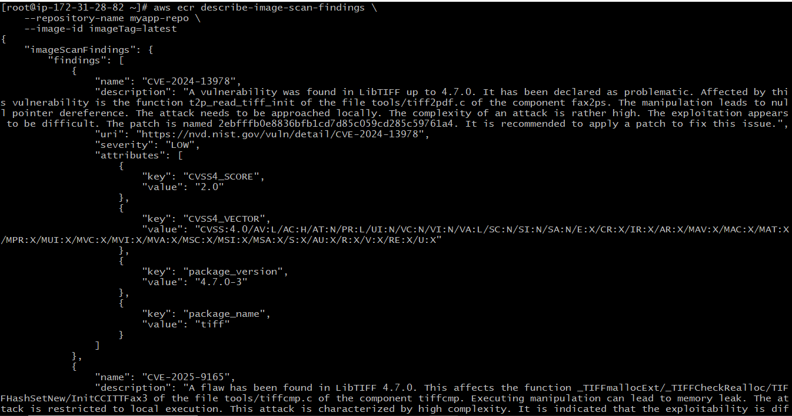
view them in AWS Management Console → ECR → myapp-repo → Image scanning results.
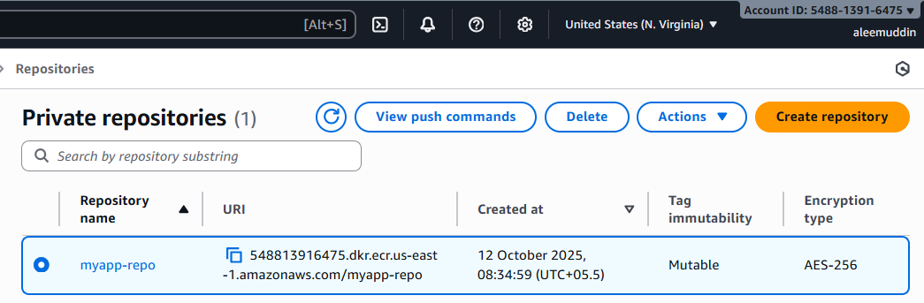
- Create a Jenkins pipeline to create a docker image and push the image to Docker hub.

GitHub → Jenkins → Docker Hub CI/CD Pipeline

1. Prerequisites

On Jenkins Server
Make sure you have:
- Jenkins installed and running
- Docker installed and running
- Git installed
- Jenkins user added to Docker group:
- sudo usermod -aG docker jenkins
- sudo systemctl restart jenkins
Required Plugins Installed:
  - Git Plugin
  - Docker Pipeline Plugin
  - GitHub Integration Plugin or GitHub Plugin
  - Pipeline Plugin

2. Add Docker Hub Credentials in Jenkins
Go to:
Manage Jenkins → Credentials → Global credentials → Add Credentials
- Kind: Username with password
- ID: dockerhub
- Username: your_dockerhub_username
- Password: your_dockerhub_password_or_token
    - GitHub repository containing:
  - Maven project (with pom.xml).
  - Dockerfile (runtime-only Dockerfile using pre-built JAR).
  - Docker Hub account and Jenkins credentials (ID: dockerhub-creds).
Jenkinsfile:
pipeline {
agent any

environment {
DOCKERHUB_USER = 'aleemuddin138'
IMAGE_NAME = 'app'
IMAGE_TAG = 'latest'
}
stages {
stage('Checkout') {
steps {
git branch: 'master',
credentialsId: 'github',
url: 'https://github.com/ALEEMUDDIN138/multi-stage-example.git'
}
}
stage('Build JAR on Jenkins Host') {
steps {
echo "Building JAR on Jenkins host"
sh './mvnw clean package -DskipTests'
}
}
stage('Build Docker Image') {
steps {
echo "Building Docker image from runtime-only Dockerfile"
script {
docker.build("${DOCKERHUB_USER}/${IMAGE_NAME}:${IMAGE_TAG}")
}
}
}
stage('Push to DockerHub') {
steps {
echo "Pushing Docker image to Docker Hub"
script {
docker.withRegistry('https://index.docker.io/v1/', 'dockerhub') {
docker.image("${DOCKERHUB_USER}/${IMAGE_NAME}:${IMAGE_TAG}").push()
}
}
}
}
}
}

4. Prepare Dockerfile
- Use runtime-only Dockerfile to avoid building inside Docker (saves memory and avoids out of memory errors):
- Push this updated Dockerfile to your GitHub repository.
Dockerfile:
# Dockerfile (runtime-only)
FROM openjdk:8-jdk-alpine
COPY target/*.jar /app/app.jar
EXPOSE 8080
ENTRYPOINT ["java", "-Djava.security.egd=file:/dev/./urandom", "-jar", "/app/app.jar"]

6. Create Jenkins Pipeline
- Go to Jenkins → New Item → Pipeline → Pipeline script from SCM.
- Choose Git, enter your repository URL, and branch (master or main).
- Use Jenkins credentials for Docker Hub (ID: dockerhub-creds).
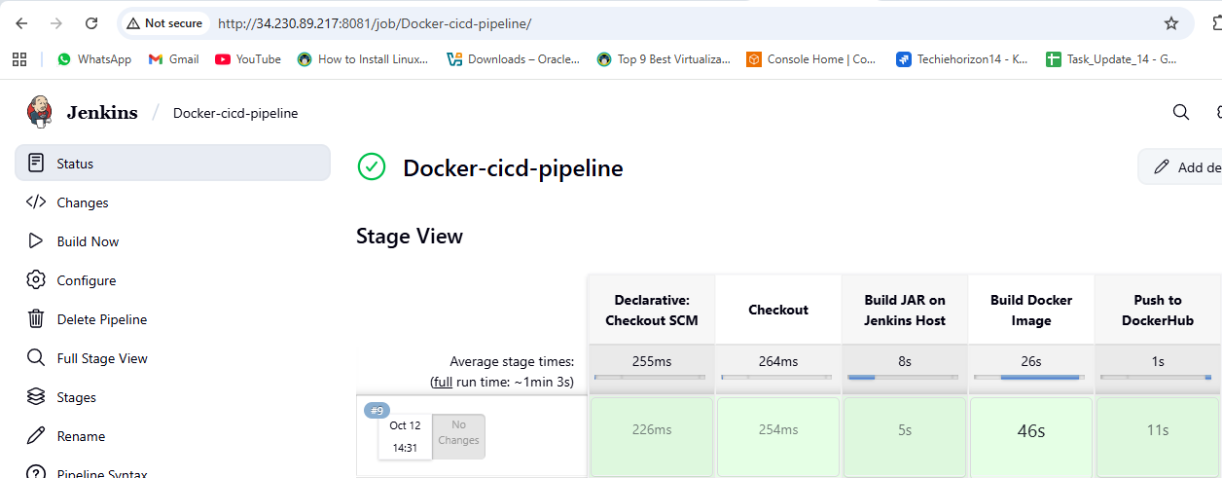

7. Verify Docker Image
docker images
docker run -d -p 8082:8080 aleemuddin138/app:latest
